EXPERIMENT 7B

DATA VISUALIZATION USING TABLEAU – Sales Dataset

Aim:
To connect, analyze, visualize, and create interactive dashboards using Tableau for effective business intelligence and data analytics.
Sample Dataset:
Sales Dataset
A synthetic sales dataset containing 80 records and 12 columns, created to analyze sales performance across regions, cities, product categories, customer segments, and payment modes using Tableau.

Algorithm 1:
Connecting Data Source
Step 1 Open Tableau Desktop
Step 2 Select Connect
Step 3 Choose Excel File
Step 4 Browse Dataset
Step 5 Open Dataset
Step 6 Verify Imported Data
Algorithm 2:
Step 1: Open a new worksheet.
Step 2: Drag Region → Rows.
Step 3: Drag Sales → Columns.
Step 4: Select Bar Chart visualization.
Step 5: Apply data labels.
Step 6: Analyze sales across different regions.

Output:
Sales by Region bar chart.
The bar chart compares total sales across North, South, East, and West regions.

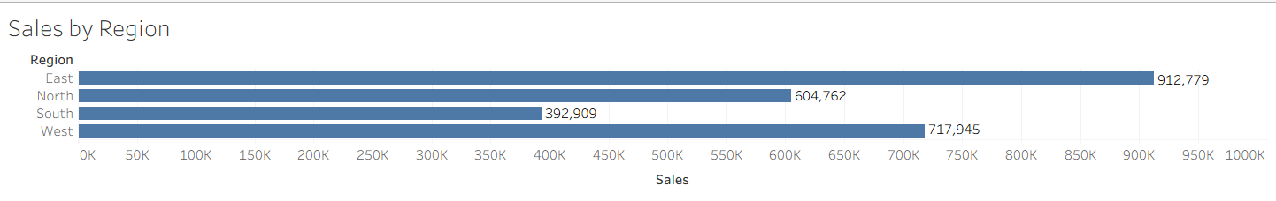

Algorithm 3:
Step 1: Create a new worksheet.
Step 2: Drag Region → Rows.
Step 3: Drag Sales → Columns.
Step 4: Select Bar Chart.
Step 5: Apply data labels.
Step 6: Format the visualization.

Output:
Sales by Region bar chart.
The bar chart compares total sales across North, South, East, and West regions


Algorithm 4:
Step 1: Create a new worksheet.
Step 2: Select Pie Chart.
Step 3: Drag Category → Color.
Step 4: Drag Sales → Angle.
Step 5: Drag Sales → Label.
Step 6: Analyze the contribution of each category.

Output:
Category-wise Sales pie chart.
The pie chart represents the contribution of Electronics, Furniture, and Stationery to total sales.
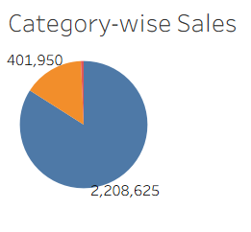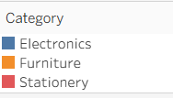

Algorithm 5:
Step 1: Create a new worksheet.
Step 2: Drag Order_Date → Columns.
Step 3: Set the date level to Month.
Step 4: Drag Sales → Rows.
Step 5: Select Line Chart.
Step 6: Apply appropriate formatting.

Output:
Monthly Sales Trend line chart.
The line chart shows the variation in sales over different months.
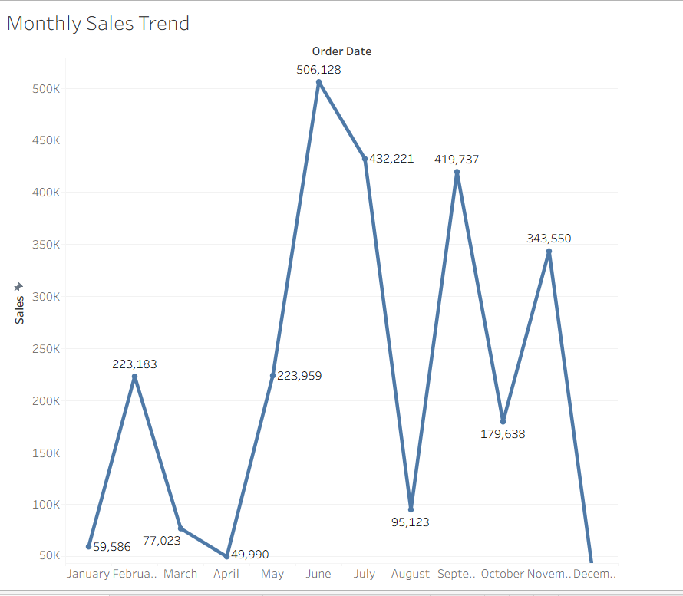

Algorithm 6:
Creating Calculated Field
Objective
To calculate the Profit Margin from Sales and Profit.
Profit Margin = SUM(Profit) / SUM(Sales) Procedure
Step 1: Select Analysis → Create Calculated Field.
Step 2: Enter the name Profit Margin.
Step 3: Enter the formula:
SUM([Profit]) / SUM([Sales])
Step 4: Click OK.
Step 5: Use Profit Margin in the visualization.
Step 6: Format the value as a percentage.

Output:
Profit Margin by Category visualization.
The calculated field helps compare the profitability of different product categories.
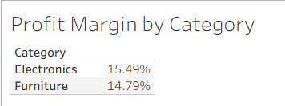

Algorithm 7:
Step 1: Select the required worksheet.
Step 2: Drag Region → Filters.
Step 3: Select the required region.
Step 4: Apply the filter.
Step 5: Observe the updated visualization.

Output:
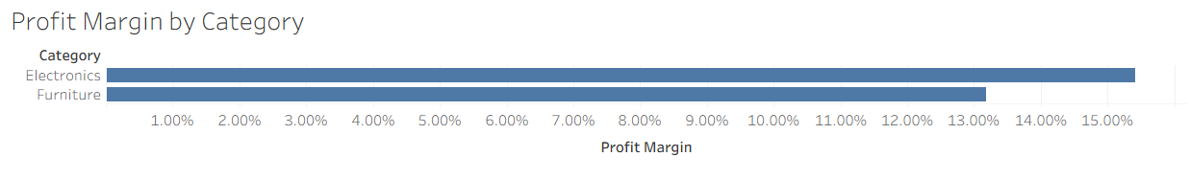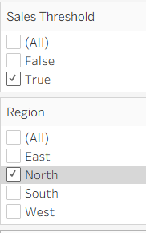
Algorithm 8:
To analyze sales records based on a user-defined minimum sales value.
Step 1: Select Analysis → Create Parameter.
Step 2: Name the parameter Minimum Sales.
Step 3: Set the data type and allowable range.
Step 4: Create the calculated field Sales Threshold.
Step 5: Use the formula:
[Sales] >= [Minimum Sales]
Step 6: Apply Sales Threshold = True as a filter.
Step 7: Display the parameter control.
Step 8: Change the minimum sales value and observe the updated visualization.

Output:
Interactive Minimum Sales Parameter.
The parameter allows users to dynamically analyze sales records above a selected sales threshold
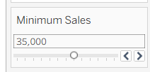

Algorithm 9:
Step 1: Create the required worksheets.
Step 2: Select Dashboard → New Dashboard.
Step 3: Drag the worksheets onto the dashboard.
Step 4: Arrange the visualizations appropriately.
Step 5: Add the Region Filter and Minimum Sales Parameter.
Step 6: Format the dashboard.
Step 7: Save the dashboard.

Output:
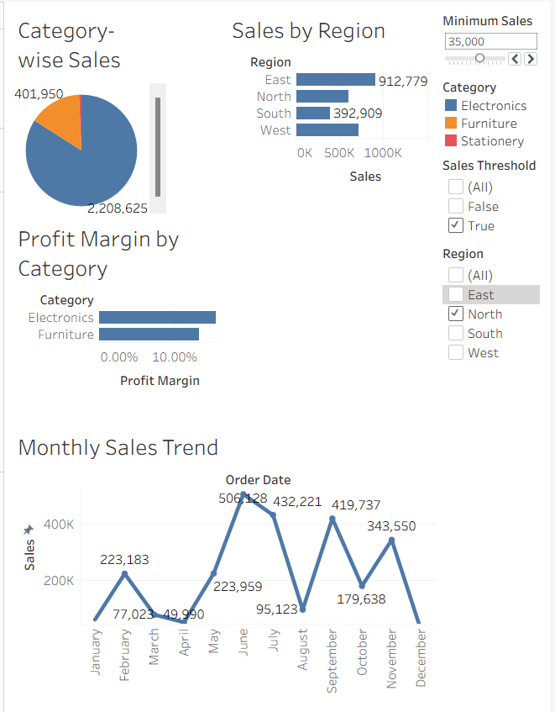

Result:
Thus, Tableau was used successfully to connect datasets, create worksheets, apply filters and parameters, generate visualizations, build dashboards, and create stories for business intelligence and analytical decision-making.

